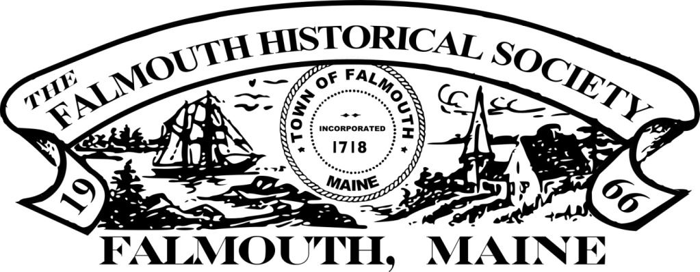
Membership Report
September 13, 2022
 | Primary | Family | Sponsors | Total
Current members | 47 | 8 | 4 | 59
Members pending renewal | 26 | 10 |  | 36
Total | 73 | 18 | 4 | 95
Lapsed | 8 | 1 |  | 9

